Drosophila Virtual Lab

Drosophila or fruit flies are another important model species. They can reproduce quickly, survive well in the lab and they have a relatively simple genome.

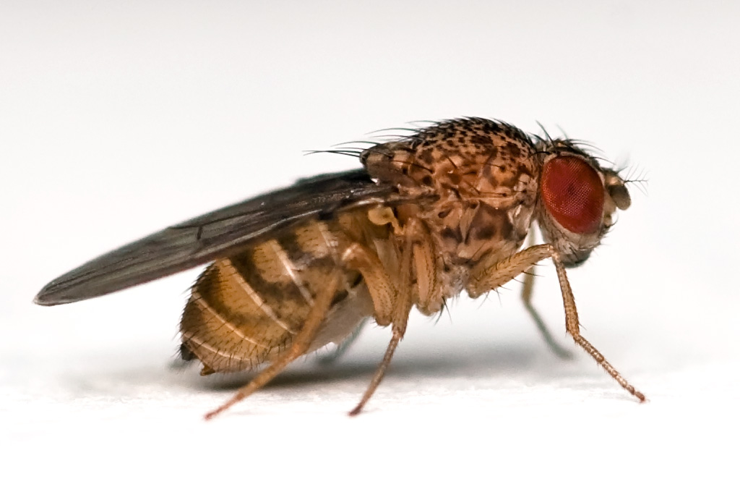
The females are slightly larger than the males and have a more pointed rear. The males also have sex-cones on their front legs.
The normal phenotype is the wild variety, which is homozygous dominant for many common traits such as body color and wing shape.

Instructions

Go to http://www.sciencecourseware.com/vcise/drosophila/ and log in as a guest.
You will need your lab book to record your results. You may work in groups of 2-3 people. This will be marked as a lab grade so you will all need to record the individual steps that you take, any hypotheses that you make as well as record your results.
Once you are logged on and have entered the fruit fly lab follow the following instructions:

Task 1
- Click on order flies.
- Select a wild type female fly.
- Order a male fly with a black body.
- Once you have selected the flies’ checkout and they will be delivered to your lab.
- Click on the flies to place them in the mating jar.
- Click on the mating jar to place it into the incubator – wait two weeks.
- Click on the incubator and select the mating jar to prepare the flies for analysis. They will be sedated with ether but otherwise unharmed.
- Click on the “sort flies tab”.
- Click on both groups and record the phenotype.
- Draw a Punnett square of your hypothesis of what the genotypes of the F₁ cross would be, you will need to assign letters to each of the selected traits. Normal fruit fly nomenclature can be confusing so you can use any letter you choose to represent the alleles.
- Select both groups for a new mating jar.
- Mate the F₁ flies to produce the F₂ generation
- Analyze the F₂ generation under the microscope.
- Draw a Punnett square for your hypothesis of the F₂ generation genotypes. Do these resemble the phenotype ratios that Mendel observed in his pea plant experiments?

Task 2
- Clear the incubator of old flies by clicking on the trash can.
- Order new flies, a wild female and a male this time make sure the male fly has 2 traits that vary from the wild type (use black color and scalloped wing shape).
- Repeat steps 5 to 14 for the new F₁ and F₂ generations, remembering to draw Punnett squares for each generation as you go. As there are two traits being analyzed we will be looking at a dihybrid cross. Remember when you draw your Punnett squares you are replicating the action of meiosis so represent the gametes correctly. Which of Mendel’s principles is represented in this dihybrid cross?

Once you have completed both tasks write up a set of conclusions about the observed traits and suggest why drosophila are such a good species to use for genetic experiments. In general how might the observations we made have changed if we had picked two traits that lay on the same chromosome? Also what might the effects be if we picked traits that were located on the sex chromosomes?

Rubric:
Total points: 40
Introduction – define genetics. Define what a model system is. Why are Drosophila a good organism to study?
Punnett squares: 20 points (5 points per generation, e.g. F₁ = 5 points)
Conclusions and question answers: 10 points

