The Heart
Label the diagram below and color the heart to help highlight the different structures.
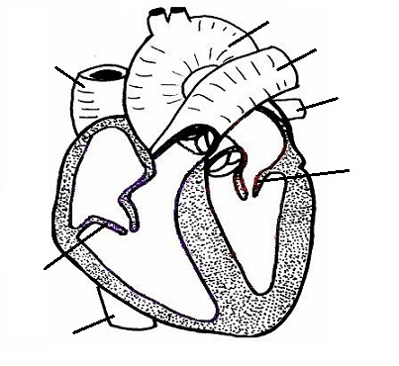
Describe the flow of blood within the heart. Be sure to explain the role of valves, arteries and veins. Make sure you mention the oxygen content of the blood as it passes through the heart. What do the terms systole and diastole mean?

